Instructions for Multiple
Accounts Login

Knowledge Base Article

Table of Contents

Overview 3
Login Instructions for Accessing Multiple Applications 3
For Login as APS User (OHID Configured user) 3
For Login as OCAF User 4

Overview
This guide provides instruction on how to Login to JFS org when multiple accounts are present for single user.

In JFS org, APS users are configured with Salesforce platform license and most of the other applications are configured with Salesforce license. A salesforce platform license can’t access Salesforce license applications. If a user requires APS and any other application access, two users are created in JFS org with two different licenses. One user is to access to APS application and other is to access all other applications.
In case of two users, one user needs to login with OHID, and another user needs to login by using Username and Password.

Login Instructions for Accessing Multiple Applications:

For Login as APS User (OHID Configured user)
Login URL: https://odjfs2.my.salesforce.com
1. Click on Log in with Staff/County User.
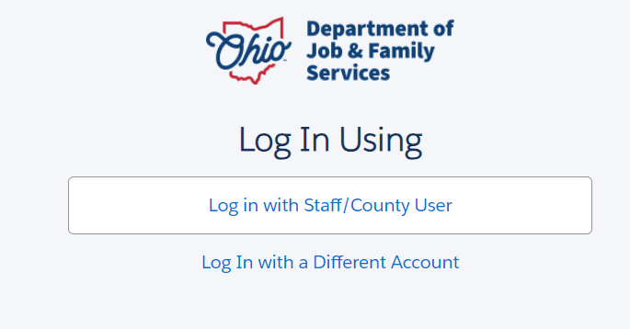
2. Enter OHID and Password.
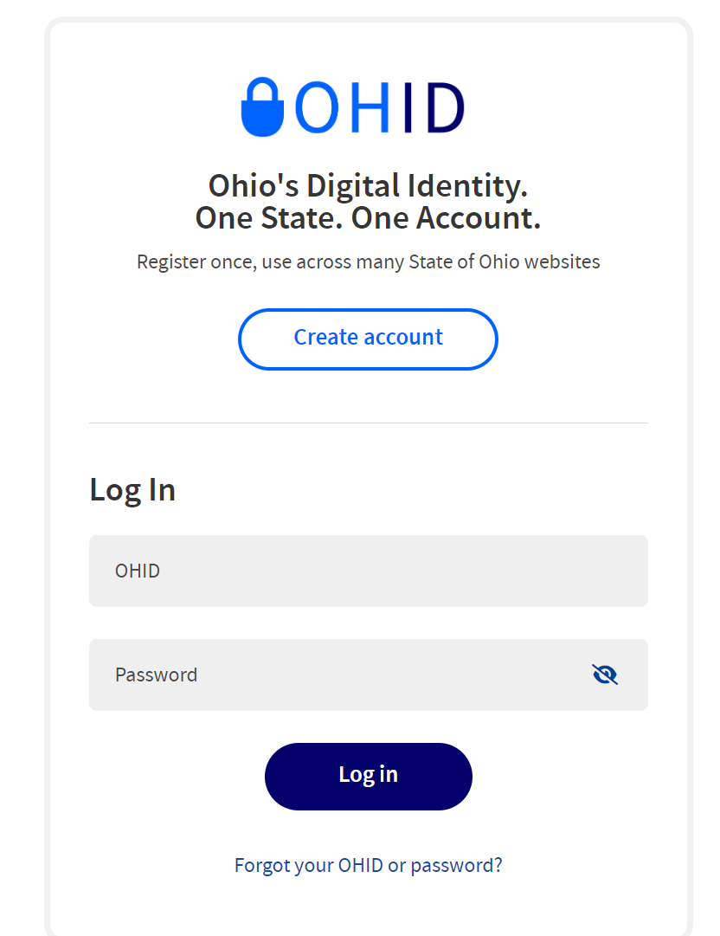

For Login as OCAF User:

Click on Login URL: https://odjfs2.my.salesforce.com

1. Click on Log In with a Different Account button.

2. Enter Username: you might have received an email with username.

3. Password: Password reset for this user, please refer email, and set the password and login to application.

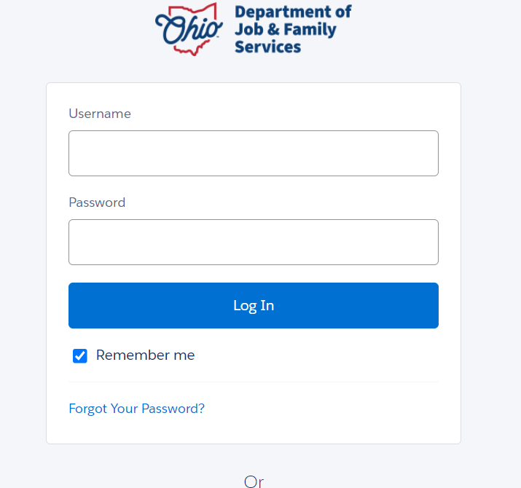

If APS application access is not required, we can configure the OCAF/DCY user with OHID, so that OCAF/DCY application can be accessed with OHID. Please let us know if it needs to be changed.

If you have additional questions pertaining to this Deployment Communication, please contact the Customer Care Center.

